AAR: Plandemic

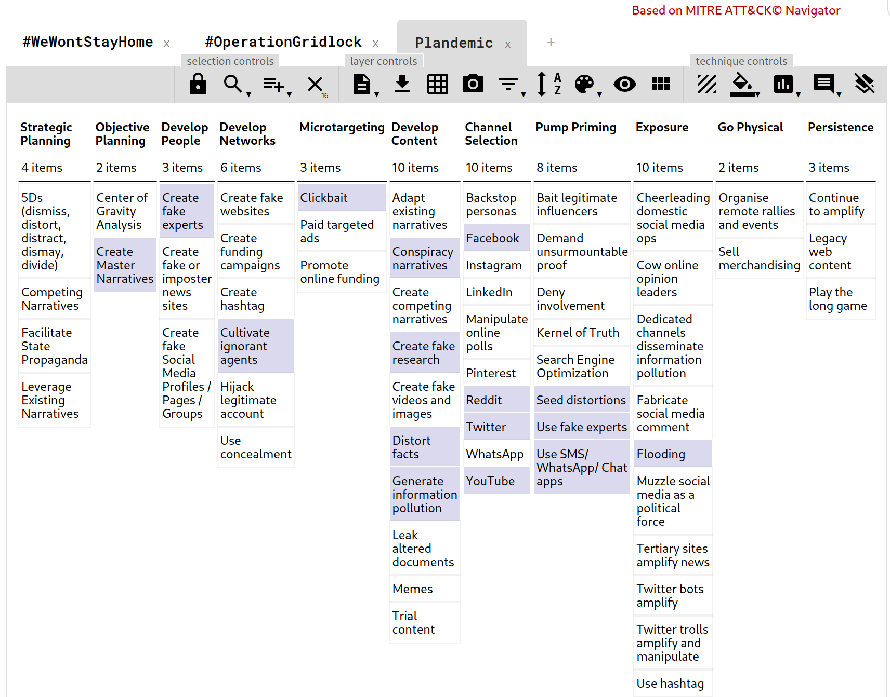



Photo: NBC News, Salem, Oregon, USA